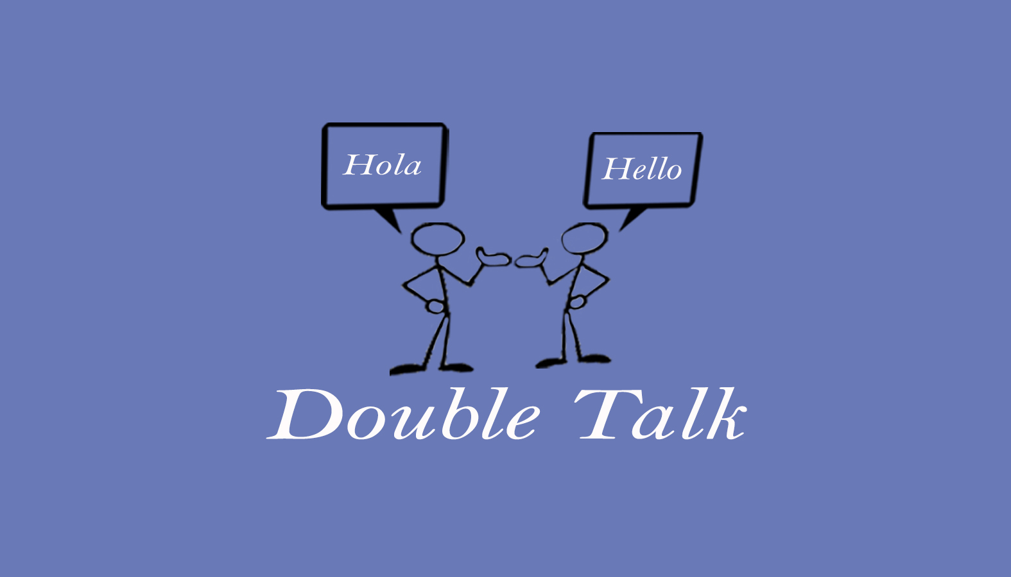
Double Talk – Bilingual Speech Therapy Services
Krista Hammer, MS, CCC-SLP
240 Redtail Road, Suite 12 A
Orchard Park, NY 14127
hammerdoubletalk@gmail.com
(716) 608-2988 ofc. / (716) 608-2942

Authorization to Exchange, Obtain
or Release Information

Client Name: _____________ Date of Birth: __________
Home Address: ______________________________________________
____________________________________________________________

I __________________________ (client or family member) hereby grant [Double Talk / Krista Hammer] permission to communicate with the following person or agency:

Name:

Contact Information:

Information to Be Released:
☐ Medical History
☐ Therapy Evaluation
☐ SLP ☐ OT ☐ PT ☐ Other: _______________
☐ Treatment Notes
☐ SLP ☐ OT ☐ PT ☐ Other: _______________
☐ School Records (Evaluations, IEP, academic reports, etc.)

For the Purpose Of: (check all that apply)
☐ Coordinating care with other professionals
☐ Providing continuity of services
☐ Updating therapeutic progress
☐ Other ________________________________________________________

☐ I grant permission to exchange information via written and mailed report, phone call, meeting, email, or fax.
☐ I understand that unless revoked, this authorization will remain valid until written revocation of this authorization is presented.

_____________________________ _____________________
Print Name of Client Date
_____________________________ _____________________
Signature of Client or Legal Representative Relationship to Client
Authorization to Exchange, Obtain or Release Information

