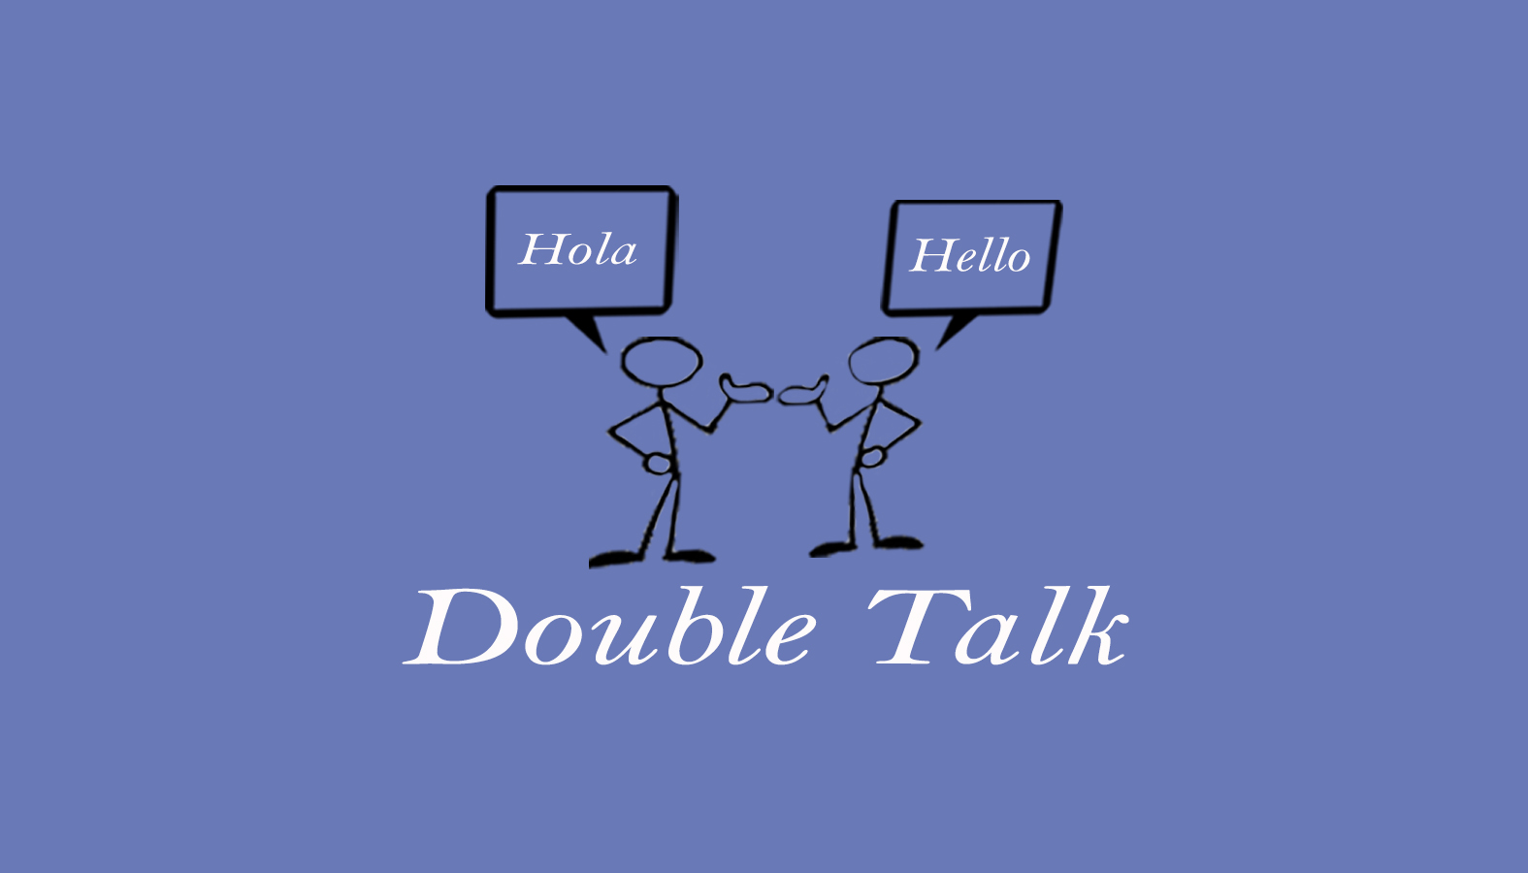
Double Talk – Bilingual Speech Therapy Services
Krista Hammer, MS, CCC-SLP
240 Redtail Road, Suite 12 A
Orchard Park, NY 14127
hammerdoubletalk@gmail.com
(716) 608-2988 ofc. / (716) 608-2942 fax

Consent for Services

☐ I authorize Krista Hammer, MS, CCC-SLP to render appropriate evaluation and therapy services to the client named below in accordance with state and federal laws. I understand that care will be provided by a qualified, licensed, and trained health professional. I recognize, agree and understand that I have the right to refuse treatment or terminate services at any time by Krista Hammer, MS, CCC-SLP in writing. In addition, Krista Hammer, MS, CCC--SLP may terminate services by notifying me in writing.

☐ I do not give my consent or am withdrawing my consent regarding Krista Hammer, MS, CCC-SLP rendering evaluation and therapy services to the client named below.

_____________________________ _____________________
Print Name of Client Date

_____________________________
Client Date of Birth

___________________________________ _____________________
Signature of Client or Legal Representative Relationship to Client

Consent for Services

