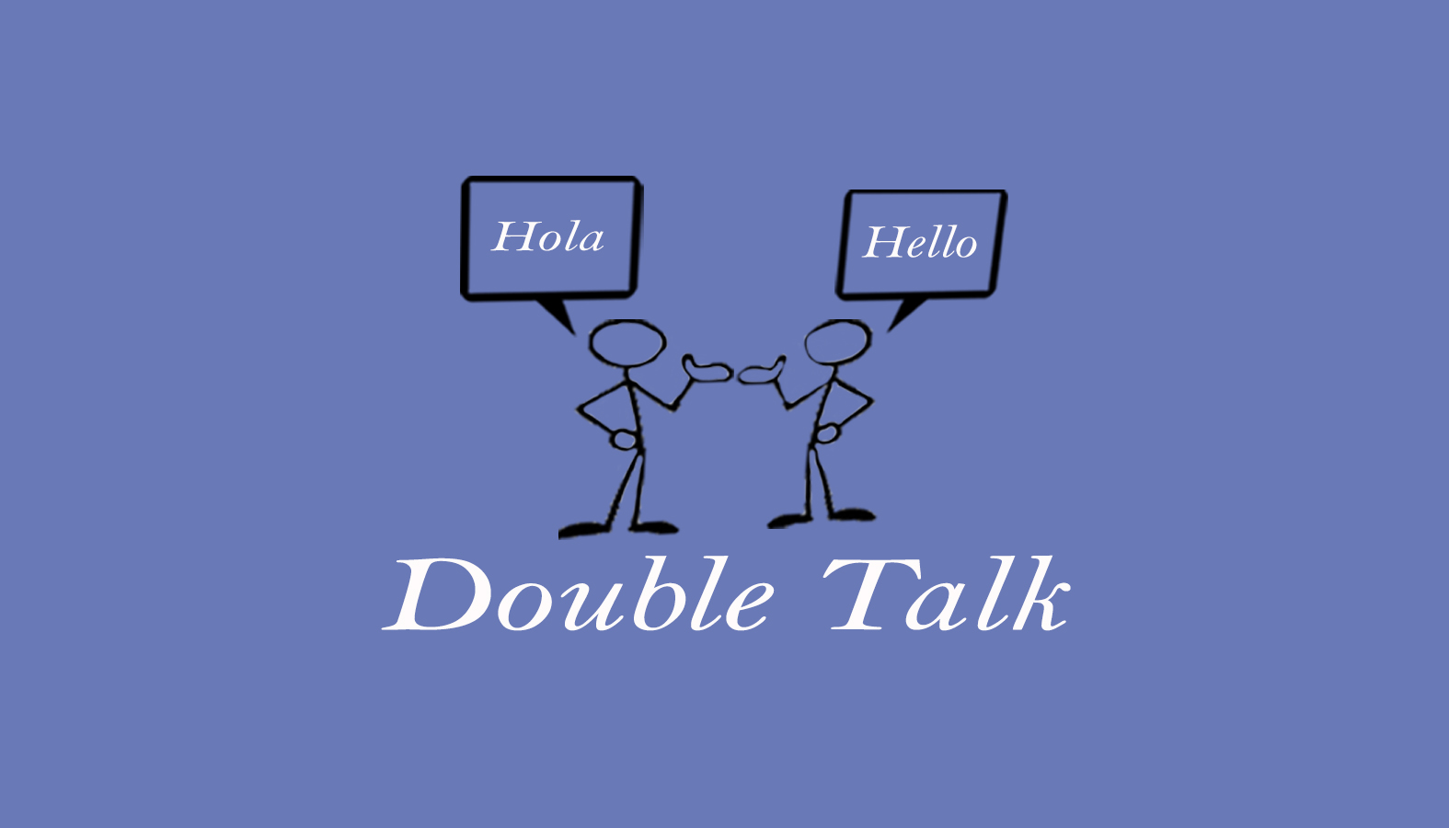
Double Talk – Bilingual Speech Therapy Services
Krista Hammer, MS, CCC-SLP
240 Redtail Road, Suite 12 A
Orchard Park, NY 14127
hammerdoubletalk@gmail.com
(716) 608-2988 ofc. / (716) 608-2942

General Acknowledgement of Forms

☐ I hereby acknowledge and agree that I read all of the forms and documents provided to me in connection with the evaluation and treatment provided by Double Talk – Bilingual Speech Therapy Services
Krista Hammer.

☐ I fully understand the meaning and intent of the forms provided and I agree to all content included.

☐ I have been given an opportunity to ask questions about the forms provided. All my questions have been answered to my satisfaction by Krista Hammer.

_____________________________ _____________________
Print Name of Client Date

_____________________________ _____________________
Signature of Client or Legal Representative Relationship to Client

General Acknowledgement of Forms

