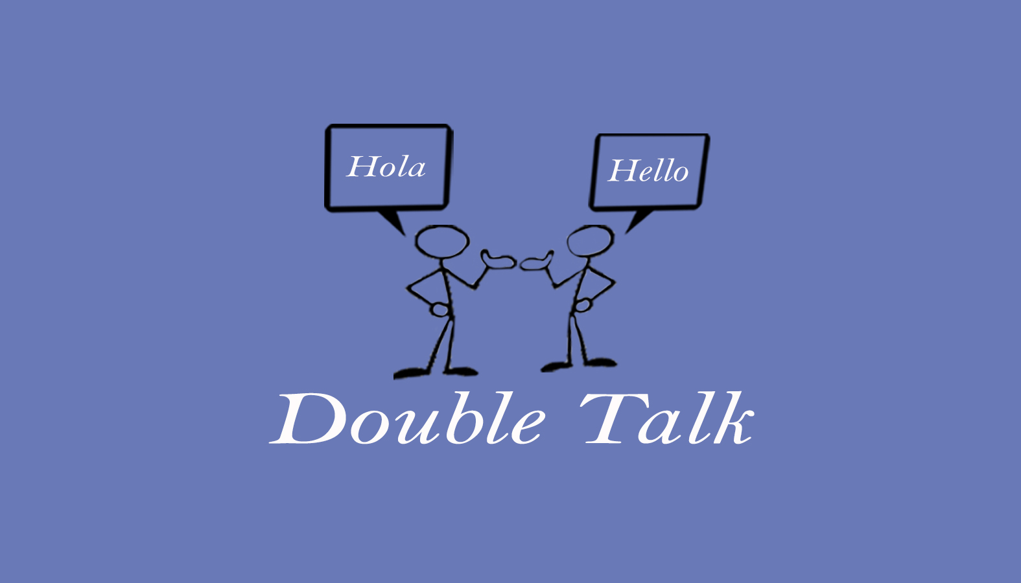
Double Talk – Bilingual Speech Therapy Service
Krista Hammer, MS, CCC-SLP
240 Redtail Road, Suite 12 A
Orchard Park, NY 14127
hammerdoubletalk@gmail.com
(716) 608-2988 ofc. / (716) 608-2942

Payment Policy

Thank you for choosing Double Talk private practice to serve you. We are committed to providing you with the highest quality care. Please know that the timely payment of your bill is an integral part of our service and as such, this payment policy is an agreement between you and Double Talk- Bilingual Speech Therapy Services for payment of services provided. By signing this policy, you are agreeing to pay for services provided to you or your family member. As a client of Double Talk – Bilingual Speech Therapy Services/ Krista Hammer you are required to carefully review and sign the payment policy.

Please read the following information carefully:

All therapy fees (including session fees and/or co-pays, if applicable) are due: At the time of service.

The following payment methods are accepted at this time: Cash, Check and Credit Card.

(Checks should be made payable to:)

Krista Hammer

You will be provided with an invoice outlining the services rendered and the amount charged.

Please read and check all boxes to acknowledge understanding and then sign below:

☐ I understand that I am responsible for all costs / fees that any third-party payer (ex. insurance company, private school, etc.) does not cover. In the event that a third-party payer source determines that rendered therapy services are “not covered” or otherwise denied, I will be responsible for all outstanding charges. I understand that I will be billed accordingly and will be responsible for immediate payment. I also understand that [Double Talk/ Krista Hammer] will not become involved in disputes between you and your third-party source regarding uncovered charges or reasons for denial.

☐ I understand that if fees are not paid in full, treatment sessions may be postponed or cancelled until payment is received.

☐ I understand that all returned checks will be subject to a $30.00 returned check fee. Charges incurred and not paid after 60 days may be turned over to a collection agency at the client’s expense. Overdue accounts may also be reported to a Credit Bureau.

☐ I understand that I am responsible for all legal and collection fees, which [Double Talk/ Krista Hammer] may incur if payment is not made in accordance with the terms and conditions herein.

☐ I understand that refunds will be issued only in instances of overpayment. All refunds will be processed within 7-14 days after the overpayment is discovered on the client’s bill or at the time the refund is requested. Refunds for payments made with a credit card will be credited back to the credit card used, all other refunds will be issued by a check. Client’s who used a third-party source will not be issued a refund until full payment is received from the appropriate source.

☐ I, understand that all cancellations require 24 hours notice and that there will be a $30.00 charge for any cancellations made less than 24 hours. This charge is my sole responsibility and will not be covered by a third-party source.

☐ I, __________________, (client / guardian name) understand the payment policy and the risks of not adhering to it.

_____________________________ _____________________
Print Name of Client Date

________________________________ _________ ____________
Signature of Client, Guardian or Responsible Party Relationship to Client

___________________________________ _____________________
Private Practitioner / Witness Date

Payment Policy

